CISC 251 Design Project

Dataset Overview:

The project dataset provided, consists of 238 columns and 215 rows (not including the column headers). Each column in this dataset represents a continuous variable as element concentrations, distance and depth are all measured on a continuous scale. The first “Dist” column, although continuous, cannot be used for prediction as it identifies the locations of where the samples were collected. All these continuous variables have been standardised to have a mean of 0 and a standard deviation of 1 (z-scored), These standardised concentrations are the features that will be used to build a predictive model.

The distance (Dist) column records the position along the line where each soil sample was taken, and the depth (Dpth) column indicates the depth at which each soil sample was taken. This variable, unlike distance, is relevant for the analysis as it is a property that new samples would also possess. It could potentially influence the concentration of elements if the mineral deposit influences the soil chemistry at different depths. The remaining 236 columns are named in the format of solvent - element (ex, As_ENZ, Au_ENZ, Ba_ENZ, etc), representing the concentration of various elements in the soil after being exposed to specific solvents. Each row in this dataset represents a single soil sample with measurements taken at a specific distance (Dist) and depth (Dpth) along the line. The values in the element concentration columns are the result of processing the soil with the ENZ solvent and measuring the concentrations of each element.

Since the goal of this project is to predict the presence of a mineral deposit, there needs to be a target variable that indicates whether a mineral deposit is present (1) or not (0) for each sample like that of the fraud dataset. For this, I need to create a new column in the dataset and fill it with 1s and 0s based on the sample's "Dist" value. If the soil sample falls within the mineral deposit range of distance 186.2 to 214.6, then it would be specified as a 1 otherwise it would be considered a 0.

Statistical analyses:

To understand the relationship between the different soil chemical concentrations and depth, a series of statistical analyses needed to be conducted. Starting with KNIME's **Correlation node**, the Pearson correlation coefficient was calculated for each pair of variables within the dataset excluding distance to provide a measure of the linear relationship between the element concentrations. Based on the correlation matrix that was generated (image on the left), we can see several areas of notable correlations especially in the bottom right corner (image on the right) in the GDX region from Cr_GDX to Zdr_GDX, other elements showed little to no correlation as we can see from the mostly white to red tiles. The only other noticeable corelation that I can see in this image is the top left corner which is more blue than red or white. Moving on from ENZ and following the diagonal line across the heat map, we can see how AA5 and AQR are more correlated than AA7. When developing the final model, I can filter out corelated the collated columns to reduce redundancy.

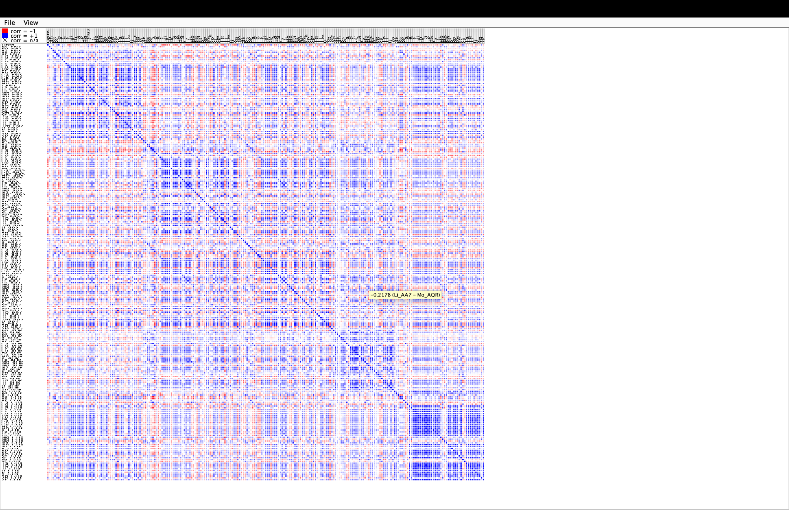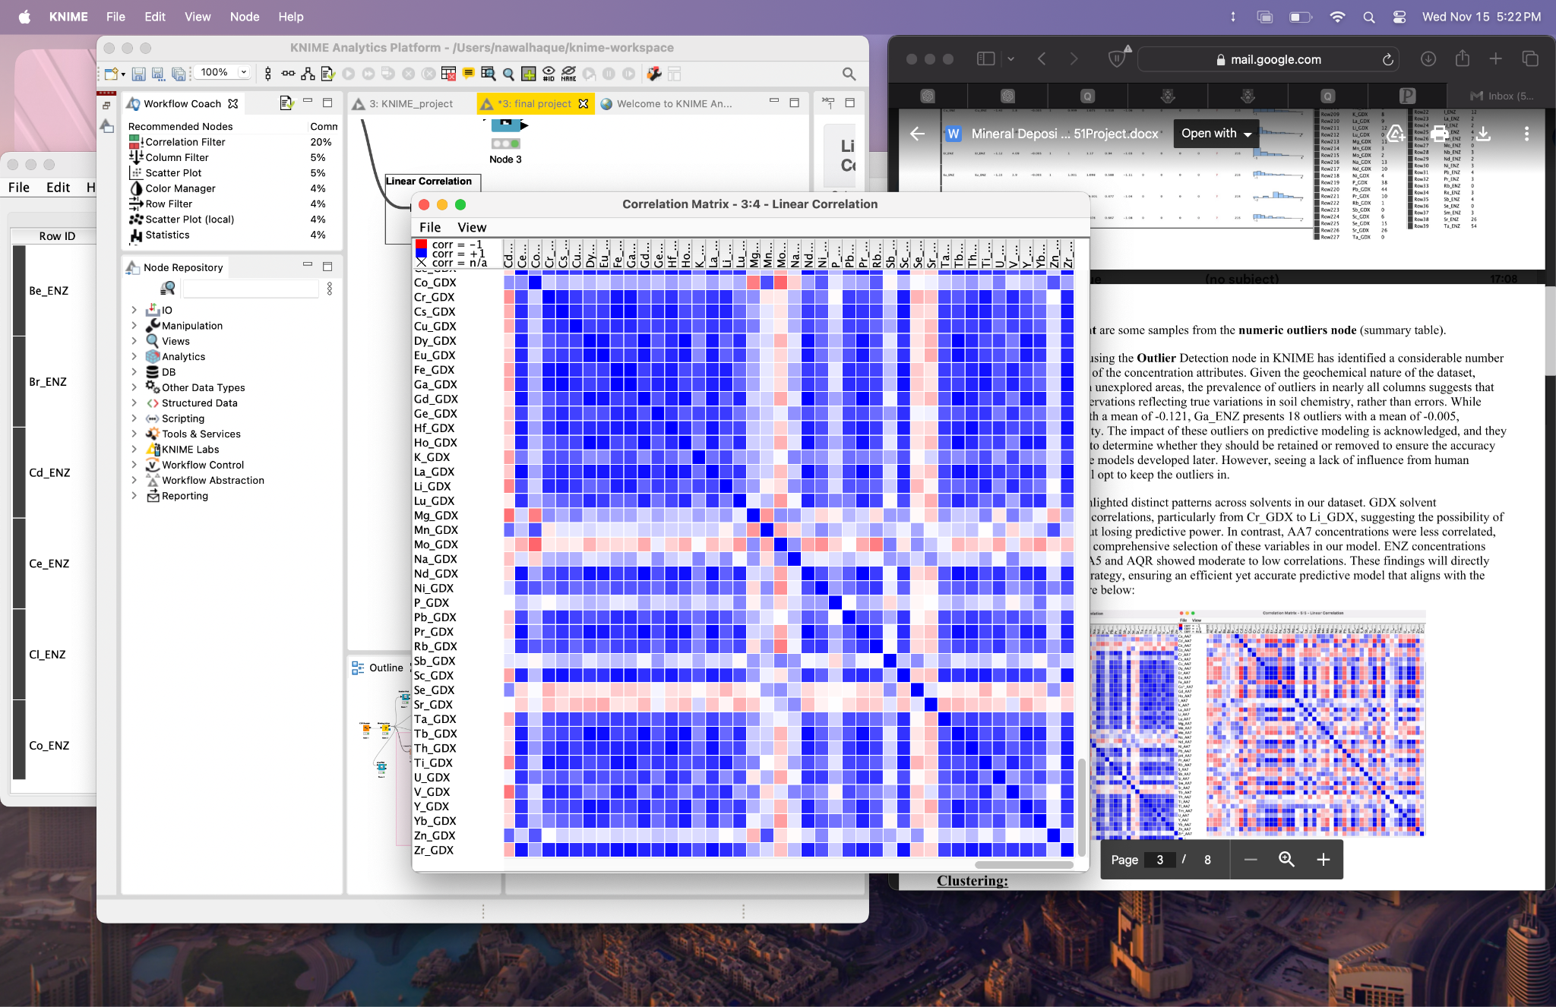

Next, using KNIME’s **statistics node,** a statistics view (image below) including max/min, mean, standard deviation and histogram among others was generated. Based on these results, we can see that although the data was z-scored as previously mentioned, the histograms, along with normal distribution, are mostly skewed positively meaning that most of the data falls on the left side of the mean. We can use this data during selection of predictive models as some predictors assume normal distribution (EM).

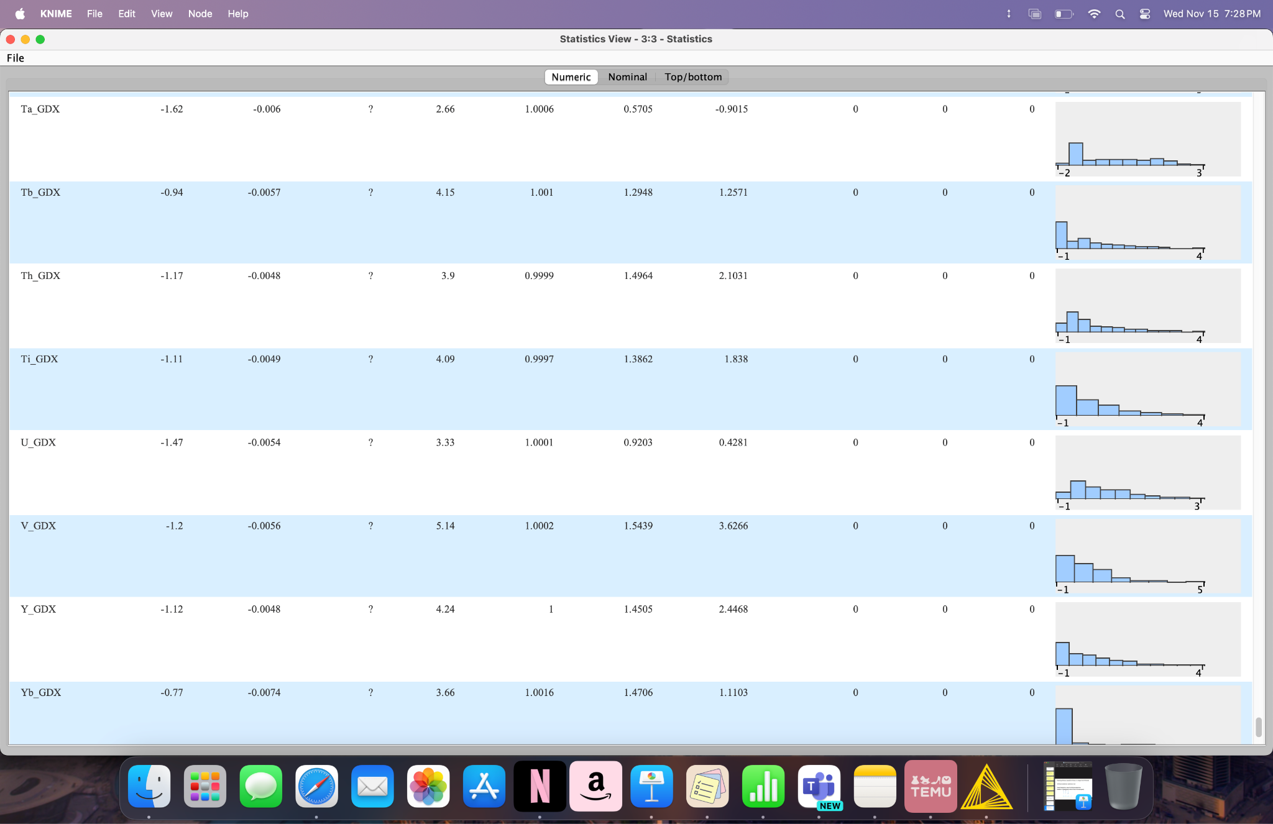

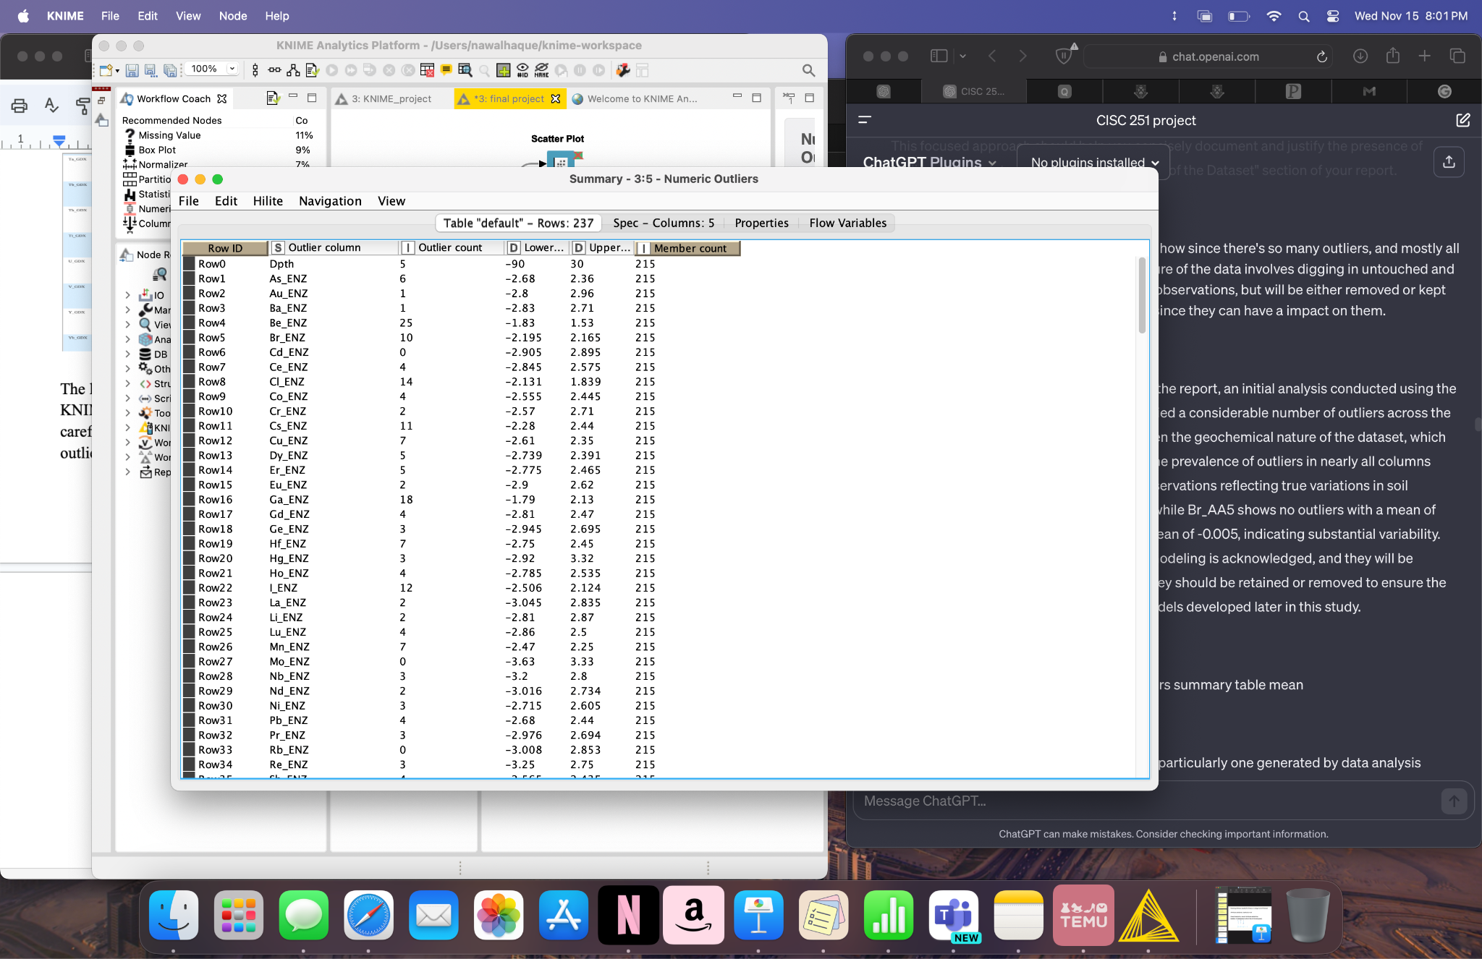The last part of the statistical analyses is to detect outliers using the **Numeric Outlier** node in KNIME. Since outliers can affect the accuracy of the prediction model, they need to be carefully considered in our dataset. The output of the node (image on the left) indicates many outliers across the different soil concentrations. Based on this we can see how the outlier count greatly varies. For now, I plan on keeping these outliers as they may represent anomalies in the soil concentrations that may be useful in my analysis. They may be treated accordingly depending on the clustering method, for example k-means.

Clustering:

K-Means Clustering

To get a baseline for clustering, I will start with K-means clustering due to its speed and simplicity. The dataset's features are continuous and standardised, making K-means an appropriate choice for initial analysis. Although this clustering method requires the number of clusters to be predetermined, I plan to use silhouette coefficients to measure the quality of the clustering based on the k-values I choose. K-means does have its limitations as it might not accurately capture the clusters if they are not spherical or have varying densities and can be altered by outliers. For this I will use the outlier node previously mentioned and move forward fully aware that the results may not be the most suitable for this high dimensional data but will assist as a baseline.

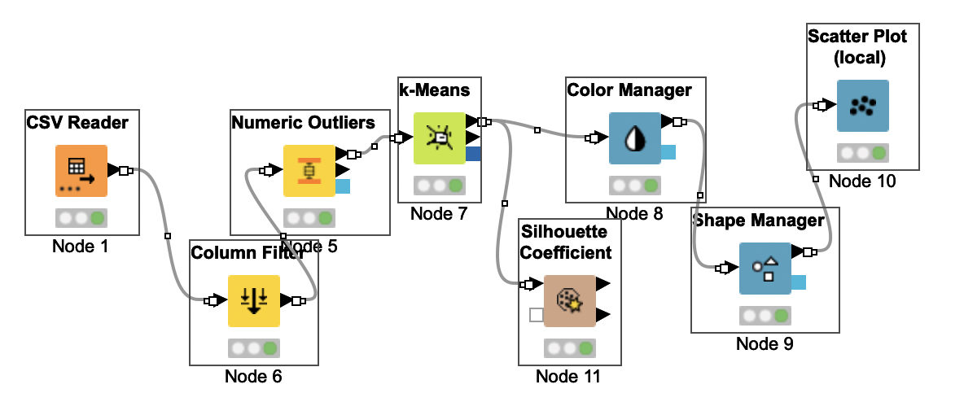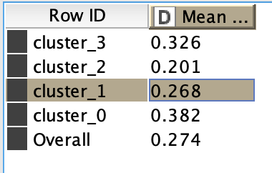

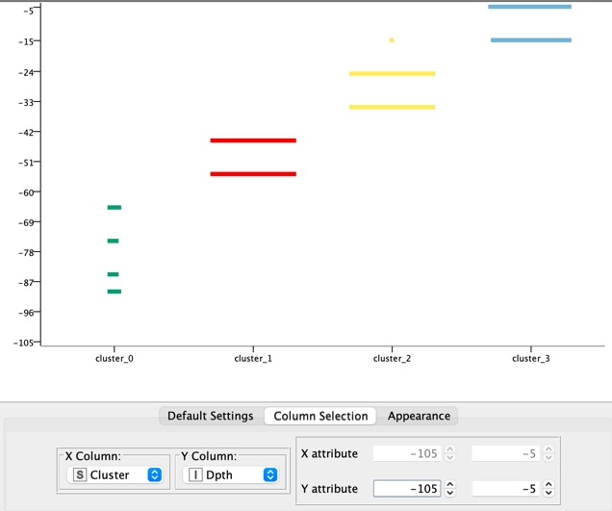During the execution of this method, I had to make a choice between the statistical quality of the clusters (as measured by the Silhouette coefficient) and the practical significance or interpretability of the results. When the k mean was higher (4), the silhouette coefficient (0.274) was lower than those associated with the k values of 3 or 2, but the scatter plot generated was easier to interpret due to a lack of overlap in depth between the 4 distinct clusters. However, the limitations of this method outlined above, indicate a need for more advanced clustering methods.

Hierarchal clustering:

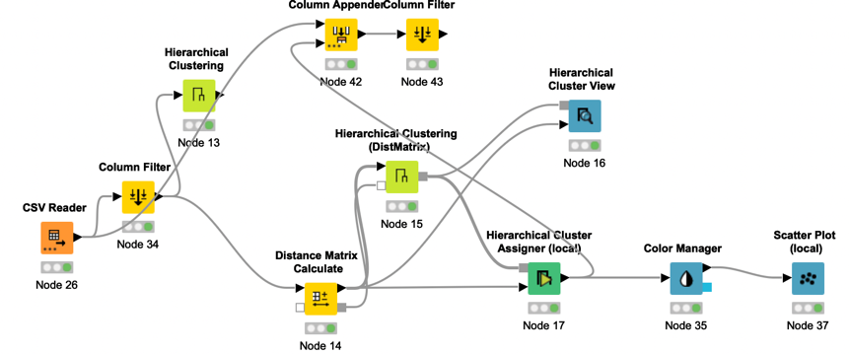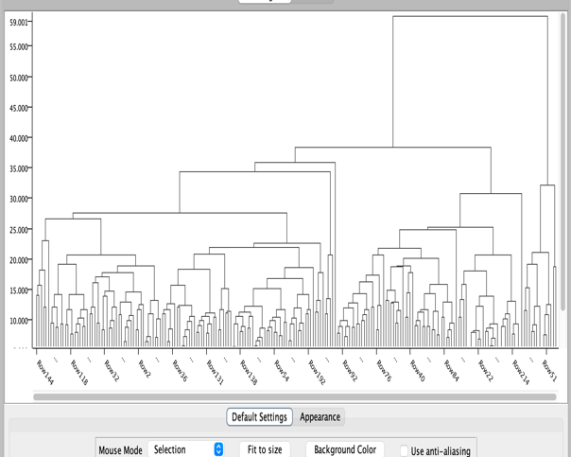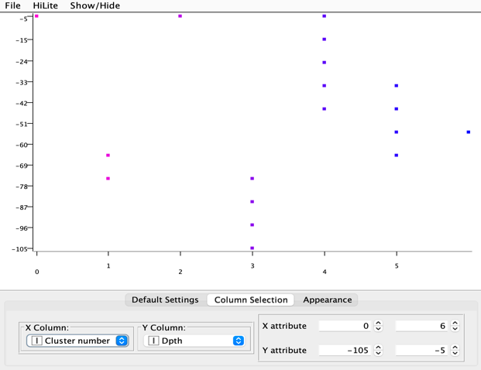Based on the initial data exploration with K-means clustering and its results, the next logical step would be to try Hierarchical Clustering. Hierarchical Clustering takes a considerably different approach compared to K-means to reveal natural hierarchies within the dataset that K-means, with its predefined number of clusters, could miss. hierarchical clustering doesn't force data into a specific number of clusters but instead reveals the data's nested clusters which may be more appropriate for geological data such as this one. In addition, our dataset is relatively small so execution of this clustering method would not be slow and could give us useful insights into the dataset that k means was unable to provide. For example, the dendrogram generated by simply adding the hierarchal clustering node into KNIME after column filter and using average linkage would allow me to estimate the optimal number of cluster to input into the hierarchal clustering assigner node. Based on the merges, it’s clear to see that 6-7 clusters would be an appropriate choice since a horizonal line around the 27-28 mark wouldn’t be too long and would be a reasonable cut as the merges at higher levels around this point indicate a higher level of dissimilarity between the clusters. Running the node with an input of 7 as the cluster gave me the scatter plot on the top right. However, like k means hierarchal clustering is also very sensitive to outliers and since this dataset contains a lot, the results of this clustering method may not be entirely suitable as I did not treat the outliers this time.

EM:

As mentioned in the dataset overview section along with right skewed histograms, the statistics node also revealed a considerable number of normal distributions within the dataset. EM (Expectation-Maximization) allows us to model each cluster with its own mean and variance making it useful for those normally distributed features. Therefore, since EM is a strong candidate for data with features that follow a normal distribution, it will be the next 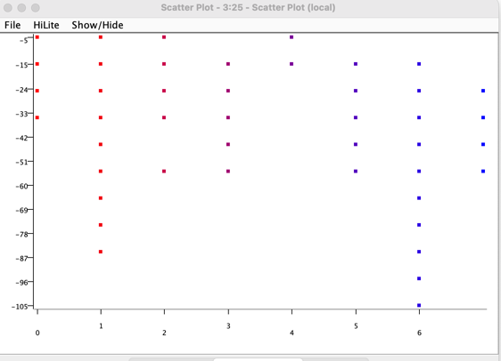clustering method I try.

To get a starting point using EM, I executed the node with its default settings. This resulted in the graph on the left with 8 clusters. Next, to compare the location of the clusters to the location of the mineral deposits I used column appender with the column filter node to view winner cluster next to distance. This allowed me to see how clusters 2, 4 5 and 8 contain no mineral deposits at all. This was however, similar to that of hierarchal clustering which gave me an estimated 7 clusters from the generated dendrogram.

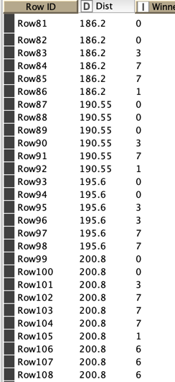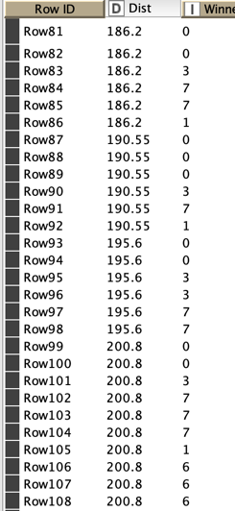 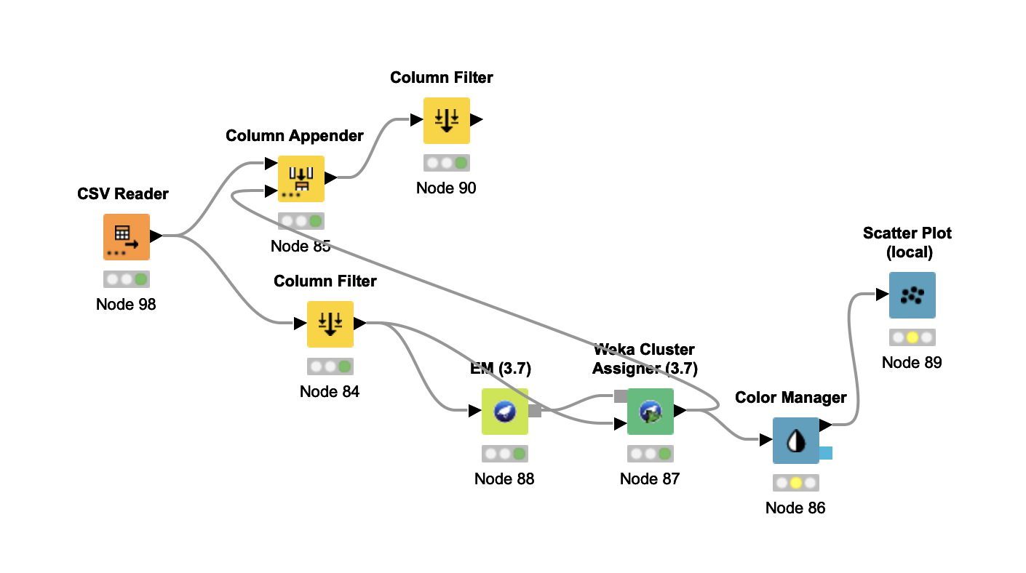

DBSCAN:

The next and final clustering method I've chosen to use for this project is DBSCAN (Density-Based Spatial Clustering of Applications with Noise). This method is a bit different from the usual clustering techniques like k-Means or EM since along with not needing to specify the number of clusters beforehand, it also doesn’t assume a certain cluster or distribution shape. This method of clustering is also good at dealing with outliers that don’t fit anywhere (which would occur a lot in geochemical datasets such as this one). Since EM assumes normal distributions and could potentially force data into somewhat rigid cluster structures, following up with DBSCAN may allow us to explore the data from a different perspective, potentially uncovering more naturally occurring groupings based on density.

In the attempt to explore the geochemical dataset through DBSCAN clustering, I encountered a consistent outcome where the algorithm identified all data points as noise, with no distinct clusters formed. This was observed across different settings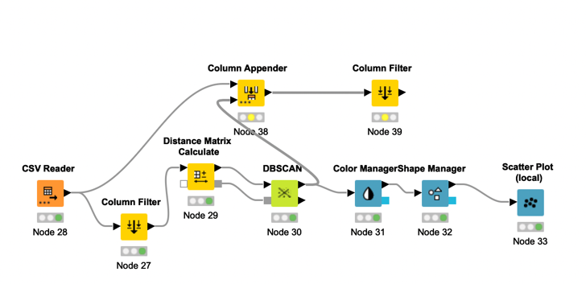 for the epsilon (ε) parameter (1, 0.5, 0.1, 0.01, 10, 100) and the minimum points value (200 and 100, 50, 1000). So, continuing to try different epsilon and minimum point values, I attempted an epsilon of 1 with a minimum point value of 1 and unsurprisingly this give me a result with 214 clusters. Then, by increasing the value of both each time and trying different combinations, I found that an epsilon value of 10 with minimum value of 5 gave me 7 clusters (picture below on right). The picture below on left depicts the scatter plot of this. Although this aligns with the number of clusters found in the previous clustering methods it is important to note what we learned in class regarding the minimum value point being higher.

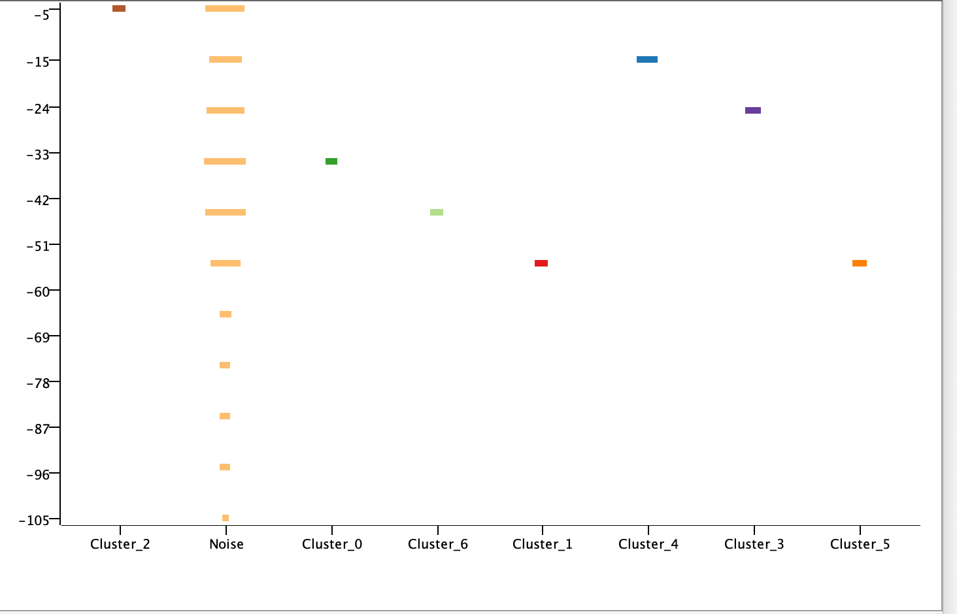 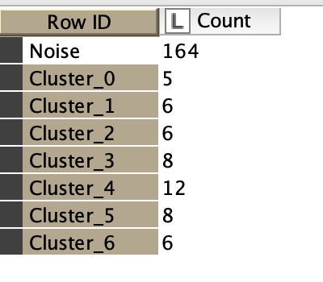

Based on the analysis and results obtained so far, I have decided to use EM and Hierarchal Clustering for the model to see how they performs when combined with the predictors from the second part. This decision is largely based on the issues associated with k means clustering, and DBSCAN. Although K-means was a good initial starting point, its results may not be suitable for this high dimensional dataset. On the other hand, DBSACN is fully suited for this data but resulted in noise when the minimum value points were higher (as they were supposed to be from lecture). As for hierarchical clustering and EM, although they both have some downsides (as mentioned previously), they seem suitable for this complex dataset, and both yielded consistent results.

Prediction:

To get started with prediction for this model I began with the creation of the target variable mentioned previously. This variable would be a new column in the dataset that would be based on whether each soil sample was within the range indicative of a mineral deposit (186.2 to 214.6) to do this in KNIME, I used the rule engine node. After importing the dataset, I configured this node to evaluate the 'Dist' column. I then assigned a value of 1 where the distance range was of 186.2 to 214.6, indicative of a mineral deposit, and 0 everywhere else. I named this new column 'Mineral Deposit'.

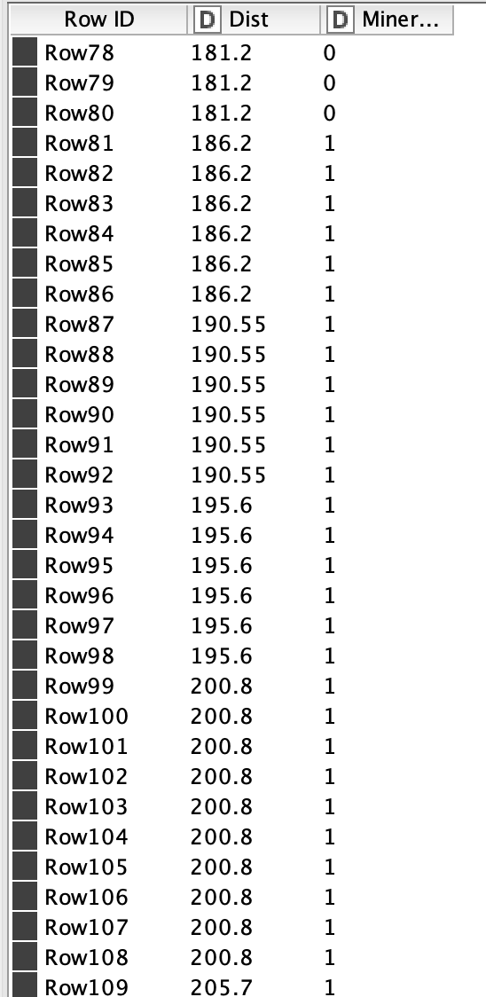 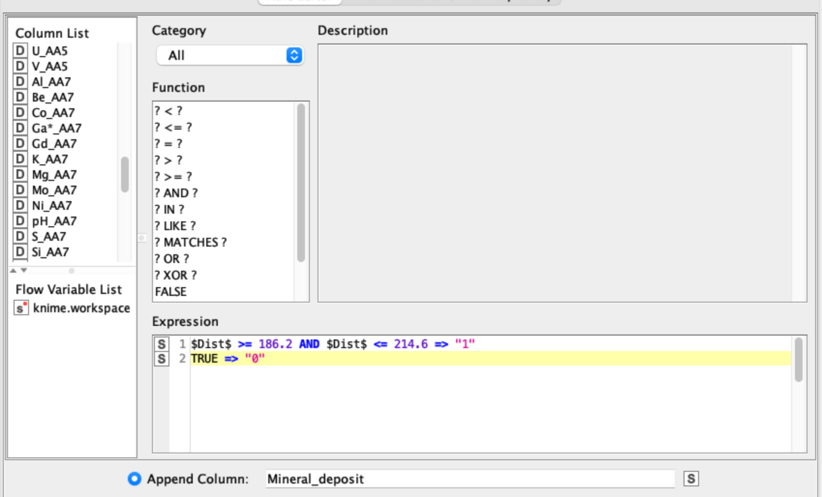

Next I will go over the 6 predictors (decision trees, kNN, random forest, SVM, Neural networks and baysion predictor) that we learned in this course to find the most aproppraite one for this model.

Decision Trees

Although decision trees are easy to use and are known for their simplicity, for our dataset, they can only offer initial insights since this dataset has a high number of features (238 columns). Decision Trees may struggle with high-dimensional data like this because they attempt to make decisions based on each feature, leading to very complex and deep trees that are not generalizable, sensitive to variation and not as effective as other. This may create issues with overfitting and since we have the option to use random forest instead, using decision trees for this model simply doesn’t make sense.

k-Nearest Neighbours (kNN)

kNN function based on the principle that similar things are near each other and so it classifies a sample based on the majority class of its nearest neighbours. However, like decision trees, the high dimensionality of the dataset is a potential issue here as well since kNN is computationally intensive when the dataset is large. It requires calculating the distance of a given point to every other point in the dataset, which can be time-consuming. When there are 215 rows and 238 columns. In addition, considering that the nature of this dataset is geochemical it is also important to note that kNN would be sensitive to the noise and many outliers it contains. Therefore, among the many prediction methods, kNN would not be wise to use for this scenario.

Naive Bayes

Bayesian methods incorporate prior knowledge and are good for probabilistic interpretations. However, this issues that arose with kNN and decision trees regarding the high dimensionality and complexity of our geochemical data are also what make Bayesian models less effective and more computationally intensive. In addition, it is important to note that the Bayesian predictor contains an assumption of feature independence, an assumption that is mostly violated by real-world scenarios such as the one in this dataset. Therefore, it would not be suitable to use this predictor in the model and we can instead use the more superior prediction methods discussed.

Random Forest

Random Forest, which is essentially a group of decision trees together builds multiple trees on different subsets of the dataset and averages their predictions, reducing the risk of overfitting. Since the dataset has high dimensionality as mentioned before and the clustering results indicated complex patterns across the different methods used, Random Forest may be a strong candidate. Specifically, it is appealing because it can handle the high dimensionality of our dataset but is still considerably simple in its parameters like the decision tree predictor.

Since I decided to use the EM clustering method for the prediction step, this is what my workflow looked like at the end with the random forest predictor:

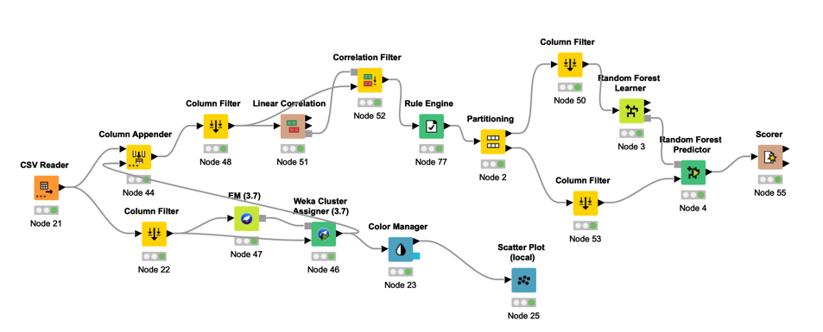The column appender allowed the distance column to be added back so that it can be used to make the target binary variable. Then the correlation and correlation filter nodes were used with a threshold of 0.8 so that the high collinearity that I mentioned previously could be addressed and redundancy can be improved. After trying several thresholds (0.7, 0.8, 0.85,0.9) I discovered that 0.8 yielded the highest accuracy of 89.231% in this model. Setting the split criterion to IGR also caused the high accuracy as both gini and IG resulted in 84%. I also found that by including the clusters found in EM into the prediction, the accuracy went down to 87% but when filtering them out and only keeping the winner cluster, the accuracy results in the 89.231% mentioned above. Finally, I tried different number of models within the random forest learner node and found that 100 models yield the 89% accuracy anything lower or higher (50, 1000, 10000) causes accuracy to decrease. Running this with cross-validation methods (x-partitioner and x-aggregator) lowers the accuracy to 85.116% (Image below) meaning the original data may have been overfit.



The next clustering method I decided to try with this predictor was hierarchal clustering. I kept the exact same predictor parameters and the same workflow as the model above and just changed the clustering method to get a final accuracy of 86.047%. 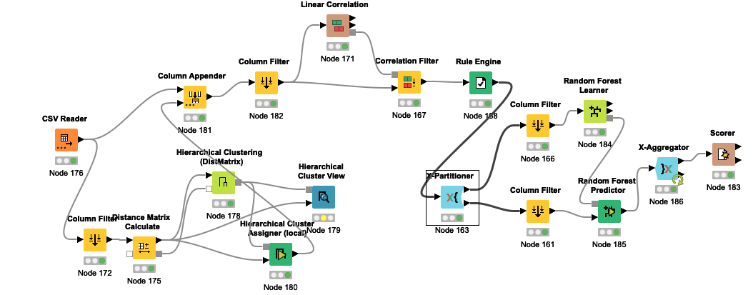 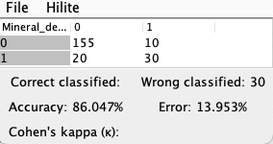

Support Vector Machines (SVM)

The main advantage of using SVM as a prediction method in this model would be due to their ability to perform effectivity with high dimensional data like this one. Not only is this method robust it is also versatile in its use of kernel functions to model a variety of different data structures. However, parameter tuning and choosing the right kernel could be potential issue but the results may overcome the downsides so I will attempt this method.

Since I decided to use the EM clustering method for the prediction step, this is what my workflow looked like at the end with SVM:

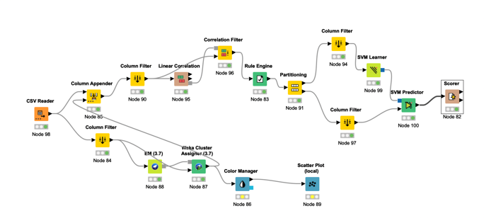I used the same setup as I did during the random forest workflow and for the same reasons. However, this time the difference is I used SVM as the predictor with a polynomial kernel set to a power of 2 and an overlapping penalty of 1. While the overlapping penalty, bias and gamma had no effect on accuracy, when the value for power was increased or decreased from 2, accuracy went down. I also tried the other two kernels, yet no configuration yielded as high of an accuracy (90.769) as polynomial did with the configurations mentioned above. However, after replacing the partitioning node with x partitioner to cross validate (10 validations) these results, I found that the accuracy went down to 86.364%. This means that the previous execution was likely overfitting to the training data.



Once again, I tried hierarchal clustering with SVM to see which clustering method would perform the best. I kept the exact same predictor parameters and the same workflow as the model above but changed the clustering method to get a final accuracy of 89.767 %. Although it is not the same value, the accuracy of the model with Hierarchical clustering and SVM is very close to EM clustering and SVM.

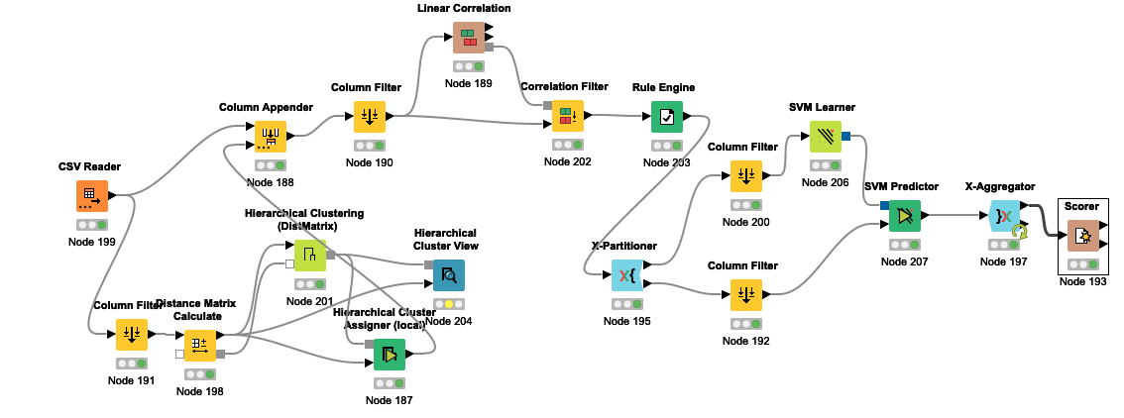 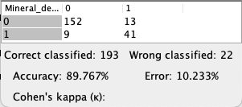

Neural Networks

Neural Networks have the ability to model highly complex, non-linear relationships with a high predictive power. This method would certainly be a plus point for this projects large dataset as it would be able to capture deeper interactions between the features. However, there are a few cons of this method specifically its requirement for parameter tuning but the 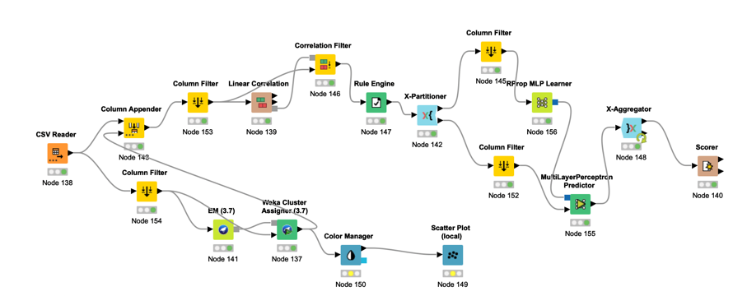outcome may overcome this issue so I will give this method a try. After employing the same general workflow as the last two times and including cross validation node with 10 validations, used the RPROP MLP learner node with a value of 10 for the hidden neuron in a layer parameter and 100 iterations to yield an accuracy of 86.512%. Other configuration that increased or decreased this value lowered the final accuracy.



Lastly, once again I tried this predictor with hierarchal clustering instead of EM to see the difference between the two. I kept the same predictor parameters as above changing only the column filter configurations. The accuracy I got running this with 10 iteration cross validation was a little surprising. It was the exact same as with EM (86.12%). 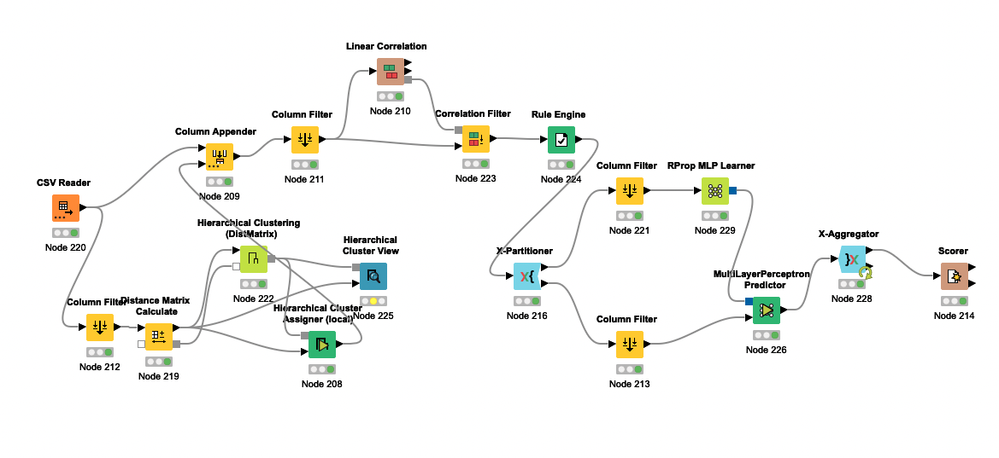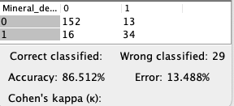

Conclusion:

In summary, by developing various models with EM and Hierarchal clustering paired with 3 different predictors (Random Forest, SVM, and Neural Networks), I found that there was a consistent accuracy of around 86% across the various models and validation techniques with some Hierarchal clustering models being slightly higher. This consistency suggests that both EM and Hierarchical clustering are effective for this dataset when combined with the chosen predictive models. The slightly higher accuracies noted for Hierarchical clustering in some scenarios could be accredited to its ability to capture the natural structure of the dataset more effectively. Since Hierarchal clustering emerges with the slightly higher accuracies in general, it would make sense to use this clustering method in the final model moving forward. Moreover, Hierarchical clustering also offers an added advantage in interpretability that EM does not, by allowing for a better understanding of the datasets underlying structure through its dendrogram generation. While EM performed just as well, it simply does not make sense to choose it over Hierarchal clustering in this scenario knowing how computationally expensive EM is in comparison. Next, in terms of predictors, SVM yielded the highest accuracy of 89.767% among the models. Although compared to the other predictors SVM requires a more complex parameter tuning the increase in accuracy seems to be a good trade off when paired with Hierarchal clustering. So, by combining hierarchal clustering and SVM predication for this dataset, I have developed a model that will not only effectively perform with high dimensional datasets even when complexity and size increase but will also remain computationally efficient.